Lauderdale Profiles

Matthew Harper, O.D. RHS ‘00
Optometrist Harper Eye Center, PLLC
Bachelor of Science in Biology, Doctorate of Optometry
University of Tennessee at Martin, Pennsylvania College of Optometry at Salus University

Q: How did you select your college major, certification program, or career path?
A: When I got to college, I did not have a definitive plan. Optometry was on a list of potential careers I wanted to pursue. It took time, but I eventually narrowed it down.
Q: What was the biggest influence in your selection of career path?
A: Friends and family were very important in the decision-making process. I have a family member that is also an optometrist. It was easy to ask him questions about the profession.
Q: If you could go back to
high school and select any elective course to take that would have better prepared you for college/career, what would it be?
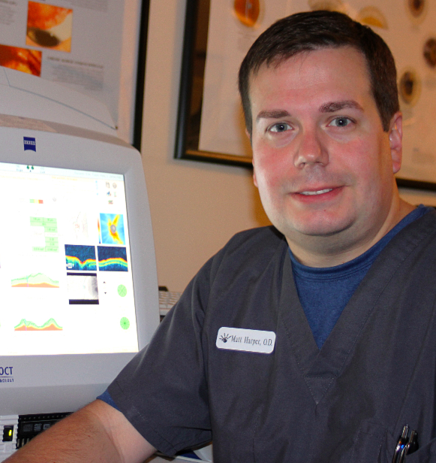
A: I would recommend taking courses in biology, chemistry, and physics. These classes are critical to performing well on the optometry admission test.
Q: What is your favorite aspect of your job?
A: I really enjoy cataract and glaucoma management.
Q: How do you/your company make a positive impact on society/our community?
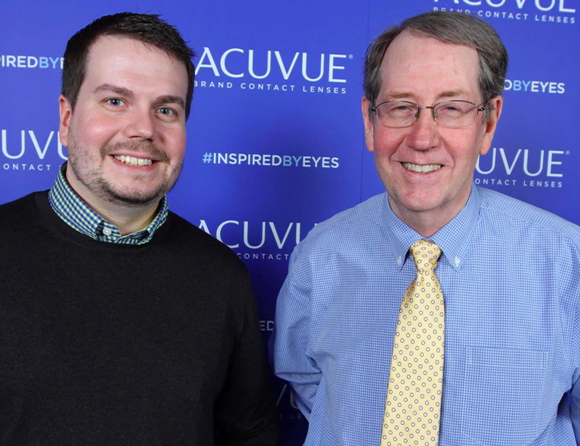
A: Our office tries to give back to the community by performing vision screenings a health fairs and community centers. We also donate glasses to other countries with the First United Methodist Church's Project 20/20 program.
Q: What’s the most interesting thing you have been able to do in your professional career?
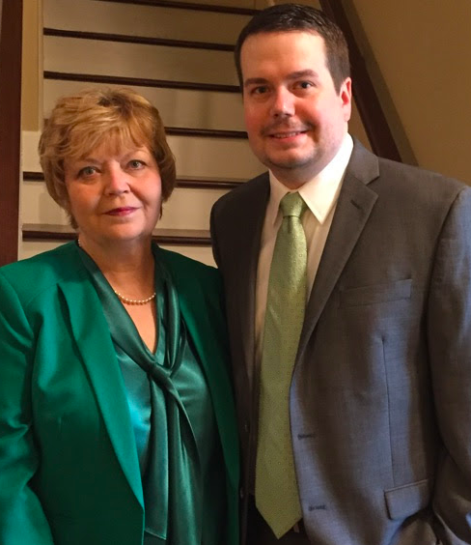
A: I really enjoy when kids put on glasses for the first time. It's fun to watch their reactions.
Q: What makes you get up each morning excited about your profession?
A: Every day is different.
Q: What advice would you share with K-12 students who are considering your profession?
A: Take advantage of learning opportunities when you are younger because they pay off when you get older.
Q: What were some of the jobs you held as a young person (summer jobs, part time work, etc.), before you were on your career path? Did they play any part in your future occupation?
A: I worked part-time for Ripley Parks and Recreation during high school and college. Having a job early on definitely helped with my understanding of time management.

